3 Days 2 Nights Cuti-Cuti Kuching Package
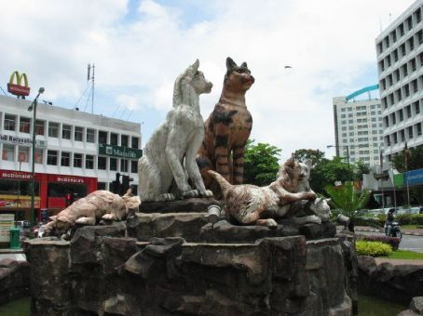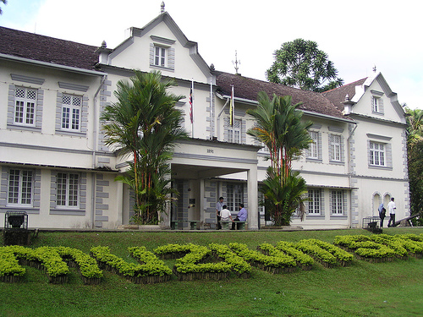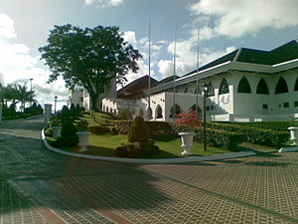

Package Rate per pax (RM)  Room based on R.O.H. |  | 2 - 3 pax  ~ seat-in-coach ~ |  | 4 – 7 pax  ~ seat-in-coach ~
 |  | Twin/Triple | Single | Twin/Triple | Single
3* Telang Usan or similar |  | 500.00 | 615.00 | 445.00 | 560.00
3* Santubong Kuching Resort |  | 615.00 | 780.00 | 530.00 | 695.00
4* Grand Margherita Hotel |  | 605.00 | 825.00 | 550.00 | 770.00
4* Damai Beach Resort |  | 650.00 | 850.00 | 565.00 | 765.00
5* Hilton Kuching |  | 670.00 | 955.00 | 615.00 | 900.00
5* Damai Puri Resort & Spa |  | 695.00 | 940.00 | 610.00 | 855.00
~ Child with ½ share twin room @ 90% of adult rate.
~ Child with extra bed @ 80% of adult rate.
~ Child without bed @ 60% of adult rate
PACKAGE INCLUDES : | ~ 2 Night accommodation at City Hotel / Resort of your choice.  ~ 2 Breakfast, 1 Lunch, 2 Dinner.  ~ Guided Kuching City Tour , Sarawak Cultural Village, Semonggoh Orang Utan,  Sarawak Pottery Factory & Shopping Tour (All guided tours are included of entrance fee)  ~ Airport – Hotel / Resort – Aiprort Return Transfer.  ~ Experienced English / Mandarin / B.M. speaking guide. (RQ before arrival)
PACKAGE EXCLUDED : | ~ Airfare & Airport Taxes.  ~ Suggested Tipping for guide/driver @ min RM 5.00 per pax per day.  ~ Optional Tour.  ~ Travel Insurance & Personal MISC Expenses.  ~ Peak Season Surcharge during New Year Day, Chinese New Year, Labour Day, Hari Gawai,  RWMF, National Day, Hari Raya, Christmas Day, July.

Itinerary :
Day 01 ARRIVAL KUCHING (D)
Meet arrival, proceed to City Tour : Ornate Chinese Temples, The Astana, City Tower,
Sarawak Museum, Cat Museum, Cat Monument, Market, Main Bazaar, China Town,
Old State Mosque, KEK LAPIS STORE. Dinner at local restaurant
After dinner, transfer to City Hotel of your choice for check in.
Free at own leisure

Day 02 KUCHING (B,L,D)
Hotel breakfast, proceed to visit SARAWAK CULTURAL VILLAGE, SEMENGGOH NATURE RESERVE, SARAWAK POTTERY FACTORY.
Lunch & dinner at local restaurant
After dinner, transfer back to Hotel for overnight
Free at own leisure

Day 03 DEPARTURE – KUCHING AIRPORT (B)
Hotel breakfast, free at own leisure until transfer to Airport for flight departure

Notes :
- The above rate are subject to acceptance of resort’s term & conditions of contracts.
- The Hotel reserves all rights to revise the contracted rates without prior notice.
- Validity : Until 31 March 2012.
- All rate quoted is base on RINGGIT MALAYSIA

